UNION EUROPÉENNE DES MÉDECINS SPÉCIALISTES
EUROPEAN UNION OF MEDICAL SPECIALISTS

SECTION OF RADIOLOGY

Survey: Radiology Workforce in Europe

With a membership in 40 countries, 60 specialist bodies, and well-established partnerships across Europe, the UEMS – European Union of Medical Specialists - represents around 1.6 million medical specialists. The Section of Radiology of the UEMS has the following objectives:
- The study, promotion and harmonisation of the highest level of training of the medical specialists, medical practice and health care within the European Union in Radiology.
- The study and promotion of free movement of radiologists within the EU, and the defence of the professional interests of European radiologists.
- The representation to EU authorities and any other authority and/or organisation dealing with questions directly or indirectly concerning the specialty of Radiology.
In order to better serve its mission, and actively collaborate with the most important scientific societies, professional and patient organisations and partners, the UEMS Section of Radiology seeks help from you as national Medical Association with reference to the most updated facts & figures on the radiology workforce in Europe. We therefore kindly ask you to complete the following short questionnaire. Thank you very much in advance for your precious help.
Questionnaire

1. Basic Information:
Country
Name of National Medical Association
Contact person (name and email) for possible further enquiries

2. Please indicate the number of practicing radiologists in your country:
Number:
As per (year):

3. Gender distribution among radiologists (in percent):
Male
Female
Other:
As per (year):

4. How many radiologists work in public/private practice (in percent)?
Public:
Public Hospitals:
Universities:
Private practice:
As per (year):

5. Age distribution of practicing radiologists in your country (in percent):
25-35 years:
36-45 years:
46-55 years:
>55 years:
As per (year):

6. Age of retirement for radiologists in your country:
Average age:
As per (year):

7. How many radiology residents (= radiologists in training) are there in your country:
Number:
As per (year):

8. Gender distribution among radiology residents in percent (if available):
Male:
Female:
Other:
As per (year):

9. Percentage of radiology residents per year of training (if available):
1st year:
2nd year:
3rd year:
4th year if available:
5th year if available:
All data as per (year):
10. Percentage of undergraduate medical students who choose radiology (if available):
Percent:
As per (year):

Table of Results

Respondent | Basic Information | N° of radiologists/gender distribution | Public/Private practice | Age distribution/age retirement | N° of residents/gender distribution | N° of residents/year of training | Percentage of medical students who choose radiology
AUSTRIA | Austrian Medical Chamber  Martina Reisinger  m.reisinger@aerztekammer.at | 1602 (updated 01.01.2019). it refers to the number of practising physicians with a specialist recognition in Radiology.  Male: 68%  Female: 32% | Public: 69%  Private: 31%  (updated 01.01.2019) | 25-35 years: 4,4%  36-45 years: 26,3%  46-55 years: 26,5%  >55 years: 42,8%  (updated 01.01.2019)  No real retirement age, but 70 is the limit age for doctors with social security insurance contract. | 259  Male: 60%  Female: 40%  (updated 01.01.2019) | Not available | Not available
BELGIUM | GBS-VBS  jpj@gerres.org | 1519 practicing radiologists/ 2164 with a diploma of radiologist (updated 2017)  Male: 64%  Female: 36%  In possession of diploma:  Male: 71%  Female: 29% | Private practice: 10% (updated 2017)  Private practice means no MRI no CT scan; there is no distinction between private and public hospitals | 25-35 years: 9%  36-45 years: 22%  46-55 years: 31%  >55 years: 38%  (updated 2017). Retirement age: no legal retirement age for independent radiologists (usually average age is 70). For employed radiologists: 67 | 256  Male: 62%  Female: 38%  (updated 2017) | 1st year: 51  2nd year: 52  3rd year: 45  4th year: 46  5th year: 50  6th and 7th years: 10 | 4,2% (updated 2013)
BULGARIA | Bulgarian Association of Radiology  Dr. Nikoleta Traikova  nikoletatraikova@gmail.com | 420  Male: 45%  Female: 55%  (updated 2019) | Public hospitals: 36%  Universities: 36%  Private practice: 28%  (updated 2019) | 25-35 years: 27%  36-45 years: 23%  46-55 years: 38%  >55 years: 12%  Retirement age: 68  (updated 2019). | N° of residents: about 120  Male: 44%  Female: 56%  (updated 2019). | Not available | 10% (updated 2019)
CROATIA | Croatian Society of Radiology  Damir Miletić, damir.miletic@medri.unir.hr | 450  Male: 40%  Female: 60%  (updated 2018) | Public: 10%  Public Hospitals: 50%  Universities: 25%  Private practice: 15%  (updated 2018) | Not available | N° of residents: 50  Male: 40%  Female: 60%  (updated 2018) | Not available | 1% (updated 2018)
CYPRUS | Radiological Society of Cyprus  Dr Eleni Eracleous elenerac@gmail.com | 62 (updated 2019)  Male: 64,5%  Female: 35,5%  A new National Health System was introduced in 2019. A significant number of radiologists have recently moved to Cyprus from abroad. In occupied North Cyprus there are about 20 radiologists, 12 men, 8 women. | Public Hospitals: 27.4%  Private practice: 72.6%  On the overall number, around 8% work in University.  Recently, there has been a significant shift from public hospitals to private practice. | 25-35 years: 5%  36-45 years: 45%  46-55 years: 30%  >55 years: 20%  Retirement age: 67  (updated 2019). | N° of residents: 5  Male: 40%  Female: 60%  (updated 2019) | 1st year: 1  2nd year: 1  3rd year: 1  4th year: 1  5th year: 1  Most radiologists are currently training in Europe and USA, only 5 in Cyprus | not available
CZECH REPUBLIC | The Czech NMA and Radiology Society do not possess such data
DENMARK | The Danish Society of Radiology does not possess such data
ESTONIA | Estonian Society of Radiology  Dr. Peeter Ross peeter.ross@itk.ee | 250  Male: 40%  Female: 60%  (updated 2019) | Public: 95% (of which in Public Hospitals: 80% and Universities: 15%)  Private practice: 5%  (updated 2019) | 25-35 years: 20%  36-45 years: 20%  46-55 years: 20%  >55 years: 40%  (updated 2019)  Retirement age: 65 | N° of residents: 58  Male: 50%  Female: 50%  (updated 2019) | 1st year: 10  2nd year: 11  3rd year: 10  4th year: 11  5th year: 16 | 7% (updated 2019)
FINLAND | The Finnish Medical Association  Dr. Hannu Halila  hannu.halila@laakariliitto.fi | 620  Male: 55%  Female: 45%  (updated 2020) | Public: 10% Public Hospitals: 45% Universities: 20%  Private practice: 25%  (updated 2020) | Age distribution: Not available  Retirement age: 65 | N° of residents: 90  (updated 2020)  Gender distribution: Not available | Not available | Not available
FRANCE | Fédération Nationale des Médecins Radiologues  Soline - soline@fnmr.org | 7474 (updated 2017)  Male: 63%  Female: 37% | Public: 2436  Private: 5038  1177 radiologists have a mixed activity (updated 2017) | 25-35 years: 11%  36-45 years: 22%  46-55 years: 24%  >55 years: 43%  (updated 2017)  Retirement age: 65 | N° of residents: 980  (updated 2018-2019)  Gender distribution: Not available | Not available | 3,15% (updated 2017)
GERMANY | Deutsche Röntgengesellschaft.  Dr. David Maintz:  david.maintz@uk-koeln.de | 8792 (updated 2018)  Male: 64%  Female: 36% | Public: 54% of which Public Hospitals: 90%  Private: 46%  (updated 2018) | 25-35 years: 6%  36-45 years: 40%  46-55 years: 35%  >55 years: 19%  (updated 2018)  Retirement age: 67 (updated 2020) | Not available | Not available | Not available
GREECE | Panhellenic Medical Association  Ms. Anna Moschona | 2.322 (updated 2017)  Male: 58,5%  Female: 41,5% | Not available | Retirement age: 67 (applicable to public hospitals) | Not available | Not available | Not available
HUNGARY | Hungarian Society of Radiology  Dr. Battyáni István mttkboss@gmail.com | 1195 (updated 2019)  Male: 33%  Female: 67% | Not available. Most of the radiologists working in the public sector have a secondary job in private practice. (Mainly in telemedicine.) | 25-35 years: 8,9%  36-45 years: 18,5%  46-55 years: 19,5%  >55 years: 53,1%  According to the current regulations, the age limit for retirement is 65 years.  (updated 2019) | N° of residents: 333  Male: 39%  Female: 61%  (updated 2019) | 1st year: 21%  2nd year: 21,3%  3rd year: 21,9%  4th year: 16,8%  5th year: 18,9%  (updated 2019) | Not available
ICELAND | Radiological Society of Iceland  marianna.gardarsdottir@landspitali.is | 45 (updated 2019)  Male: 70%  Female: 30% | Public: 65%  Private: 35%  (updated 2019) | 25-35 years: 0%  36-45 years: 25%  46-55 years: 13%  >55 years: 62%  Retirement age: 70  (updated 2019) | N° of residents: 8  Male: 87,5%  Female: 12,5%  (updated 2019) | Not available. Training is the first two years | Approximately 1-2% (updated 2019)
IRELAND | Faculty of Radiologists  Kayla Gant - kaylagant@rcsi.com | 377 (updated 2019). Numbers are taken from PCS scheme which is a requirement for all doctors in Ireland.  Male: 62%  Female: 38% | Not available, as many doctors work in both public and private hospitals without always declaring so. | 25-35 years: 1%  36-45 years: 33%  46-55 years: 36%  >55 years: 30%  (updated 2019)  Retirement age: not available, as it is not mandatory. | N° of residents: 108 (training year 2019-2020)  Male: 66%  Female: 34%  (updated 2019) | 1st year: 23%  2nd year: 23%  3rd year: 21%  4th year: 19%  5th year: 14%  The 5th year number also includes the very small number of 6th year trainees. | 5% applicants, 2% accepted (updated 2019)
ITALY | The Italian NMA and Radiology Society do not possess such data, as it is not mandatory to declare which specialty the professional belongs.
LATVIA | Latvian Society of Radiology  Dr. Gaida Krumina gaida.krumina@apollo.lv | 269 (updated 2019)  Male: 31%  Female: 69% | Public: 65%  (of which in hospitals: 70%)  Private: 45%  Out of the total, 40% are also working in universities.  (updated 2019).  Approx. 50% of total radiologists are working both in public and private practice | 25-35 years: 16%  36-45 years: 21%  46-55 years: 19%  >55 years: 44%  (updated 2019)  Retirement age: 63,5 | N° of residents: 57  Male: 30%  Female: 70%  (updated 2019) | 1st year: 28%  2nd year: 14%  3rd year: 28%  4th year: 30%  5th year: 0% | 18%  Data refers to the national competition for a residency in Radiology  (updated 2019)
LITHUANIA | Lithuanian Radiologists´ Association  Dr. Saulius Lukosevicius  saulius.lukosevicius@kaunoklinikos.lt | around 400  (20 per year are finishing residency)  Male: 30%  Female: 70%  (updated 2019) | Public: 80%  Private: 20%  Universities: 70% (on the total number)  (updated 2019) | 25-35 years: 40%  36-45 years: 40%  46-55 years: 10%  >55 years: 10%  Retirement age: 65  (updated 2019) | N° of residents: 80  Male: 40%  Female: 60%  (updated 2019) | 1st year: 25%  2nd year: 25%  3rd year: 25%  4th year: 25% | 5%  (updated 2019)
LUXEMBOURG | Société Luxembourgeoise de Radiologie  Dr. Yves Lasar lasryves@hotmail.com | 55 (updated 2019)  Male: 85%  Female: 15% | Public and Public hospitals: 100%  Private: 0 | 25-35 years: 0%  36-45 years: 10%  46-55 years: 20%  >55 years: 25%  (updated 2019)  Retirement age: 65 | Not available | Not available | Not available
MALTA | Maltese Association of Radiologists and Nuclear Medicine Physicians  Dr. Kristian Micallef kristianmicallef@gmail.com | 29 (updated 2020).  Male: 80%  Female: 20% | Public: 90%  of which  Universities: 24% and Private: 48%  (updated 2020)  Most of the radiologists who work in private practice also work in public hospitals. | 25-35 years: 10%  36-45 years: 51%  46-55 years: 10%  >55 years: 29%  (updated 2020)  Retirement age: not applicable, as all radiologists keep on practicing after reaching the current state pension age. | N° of residents: 15 (updated 2020)  Male: 33%  Female: 67% | 1st year: 0%  2nd year: 33%  3rd year: 0%  4th year: 33%  5th year: 33% | Not applicable  (updated 2020)
NETHERLANDS | Advisory Committee on Medical Manpower Planning F.deroo@capaciteitsorgaan.nl | 1260 (updated 2019). Number includes Nuclear Medicine.  Male: 77%  Female: 33% | Public: 46%  Private: 54%  (updated 2017) | 25-35 years: 6,5%  36-45 years: 38%  46-55 years: 23,5%  >55 years: 32%  (updated 2017)  Retirement age: 65-66 | N° of residents: 358 (updated 2019)  Male: 52%  Female: 48% | 1st year: 358 practicing residents in 2019; registered 1636  2nd year: 359 residents in 2018; registered 1586  3rd year: 284 residents in 2017; registered 1517  4th year: 393 residents in 2016; registered 1464  5th year: 395 residents in 2015; registered 1406  (updated 2018) | Not available
NORWAY | Norwegian Medical Association  anders.taraldset@legeforeningen.no | 877 (updated 01.01.2019)  Male: 53,8 %  Female: 46,2% | Public: 84%  Universities: 3%  Private: 13%  (updated 01.01.2019) | 25-35 years: 3,9%  36-45 years: 37,3%  46-55 years: 35,1%  >55 years: 23,7%  (updated 01.01.2019)  Retirement age: 69 (with a lot of variation) | N° of residents: 275 (updated 01.01.2019)  Male: 46,5%  Female: 53,5% | Unknown, but presumably equally distributed, possibly with some accumulation close to or even after, specialist approval. | 3% (updated 01.01.2019)
POLAND | Polish Chamber of Physicians and Dentists  Marek Szewczyński, (m.szewczynski@hipokrates.org), Agnieszka Seweryniak, (a.seweryniak@hipokrates.org) | approx. 3 700 (updated 2019)  Male: 45 %  Female: 55% | no reliable data - some doctors work both in public and private facilities | 25-35 years: 22%  36-45 years: 23%  46-55 years: 29%  >55 years: 25%  (updated 01.01.2019)  General retirement age is 60 for women and 65 for men, but not mandatory. | Not available | Not available | Not available
PORTUGAL | Still no feedback | Approx. 1100 (updated 2019)  Male: 45%  Female: 55% |  |  |  |  | 3,5%
ROMANIA | Romanian Society of Radiology  Dr. Bogdan Popa  bogdanvaleriupopa@gmail.com | 1500 (updated 2019)  Male: 56%  Female: 44% | Public: 70%  Universities: 5%  Private: 25%  A vast majority of radiologists working in public hospitals, works as part time job, in private hospitals. | 25-35 years: 25%  36-45 years: 35%  46-55 years: 25%  >55 years: 15%  (updated 01.01.2019)  Retirement age: 65 (on average) | N° of residents: 123 (updated 01.01.2019)  Male: 40%  Female: 60% | Not available | Not available
SLOVAKIA | Slovak Medical Association  Dr. Ján Čáp  jan.cap@nczisk.sk | 862  Male: 41,5%  Female: 58,5%  (updated 2019) | Public: 80%  Private: 20% | 25-35 years: 31%  36-45 years: 27%  46-55 years: 20%  >55 years: 22%  Retirement age: N/A | Not available | Not available | Not applicable
SLOVENIA | Slovenian Association of Radiology  dimitrij.kuhelj@guest.arnes.si | 200 (updated 2019).  Male: 40%  Female: 60% | Public: 90%  Private: 10%  The majority of private radiologists are being financed by the National Health Insurance. (updated 2019) | 25-35 years: 20%  36-45 years: 40%  46-55 years: 25%  >55 years: 15%  (updated 01.01.2019)  Retirement age: no data available | N° of residents: 100 (updated 01.01.2019)  Male: 40%  Female: 60% | 1st year: 20  2nd year: 20  3rd year: 20  4th year: 20  5th year: 20  (updated 2019) | 5%. The request would be higher; however, many are not selected due to limited places.
SPAIN | Spanish Society of Medical Radiology (SERAM) – Dr. Marta Serrallonga martaserrallonga@gmail.com | 5380 (updated 2019)  Male: 45%  Female: 55% | Not available among SERAM figures | 25-35 years: 28%  36-45 years: 29%  46-55 years: 18%  >55 years: 25%  (updated 01.01.2019)  Retirement age: 65 | N° of residents: 819 (updated 01.01.2019)  Male: % - 370  Female: % - 449 | 1st year: 207  2nd year: 202  3rd year: 203  4th year: 207  (updated 2019) | Not available
SWEDEN | Swedish Medical Association  hanna.vihavainen@slf.se | 1256 (updated 2016)  Male: 60,5  Female: 39,5 | Public: 81%  Private: 19%  (updated 2016) | 25-35 years: 2%  36-45 years: 30%  46-55 years: 27%  >55 years: 41%  (updated 2016)  Retirement age: no data available | N° of residents: approximately 400 (updated 2019)  Gender distribution: Not available | Not available | Not available
SWITZERLAND | Swiss Medical Association  ddq@fmh.ch | 901 (updated 2018)  Male: 69%  Female: 31% | Hospitals (both public + private structures): 65%  Private: 35% | 25-35 years: 4%  36-45 years: 27,5%  46-55 years: 35,5%  >55 years: 33%  (updated 2018).  Retirement age is 65, but there are 50 active radiologists above 65. | N° of residents: 354  (updated 2018)  Gender distribution: Not available | Not available | Not available
UK | The Royal College of Radiologists  joanna.lourenco@rcr.ac.uk | 3927 (updated 2018) This is headcount of consultant grade only (NHS and academics - not private practice)  Male: 63%  Female: 37% | Public: 98%  Universities: 2%  Private: not available  (updated 2018) | 25-35 years: 8 %  36-45 years: 40 %  46-55 years: 33%  >55 years: 19%  (2018)  Retirement age: 61 (updated 2018) | N° of residents: 1555 (updated 2018)  Male: 57%  Female: 43% | Not available | 4% (updated 2017)

Thematic Maps

Picture 1 – Responding countries
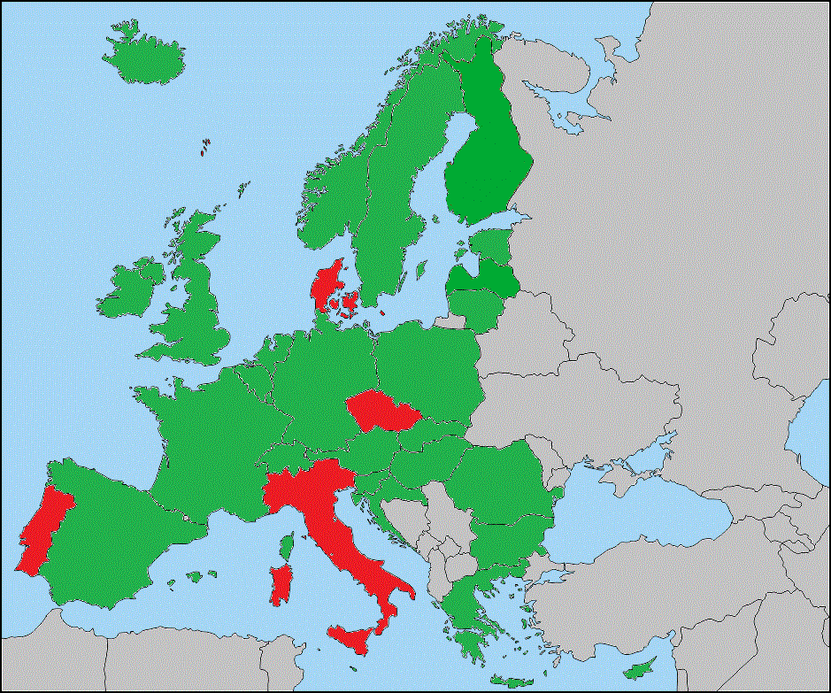
Answer
No answer
Not applicable

Picture 2 – Gender distribution of European radiologists
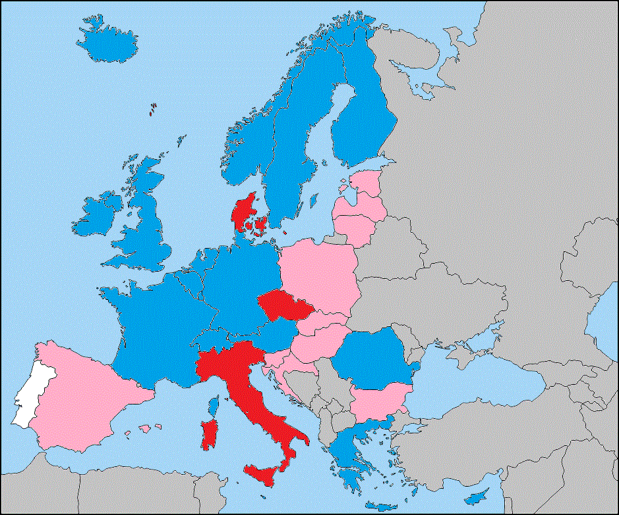
Prevalence of male radiologists
Prevalence of female radiologists
No answer
Not applicable

Picture 3 – Age of retirement
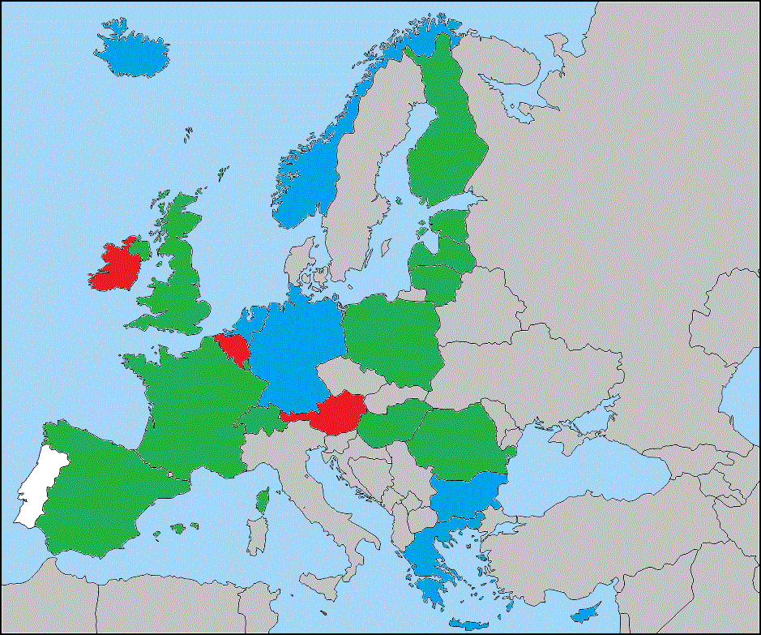
≤ 65
> 65
No legal retirement age
Not applicable

